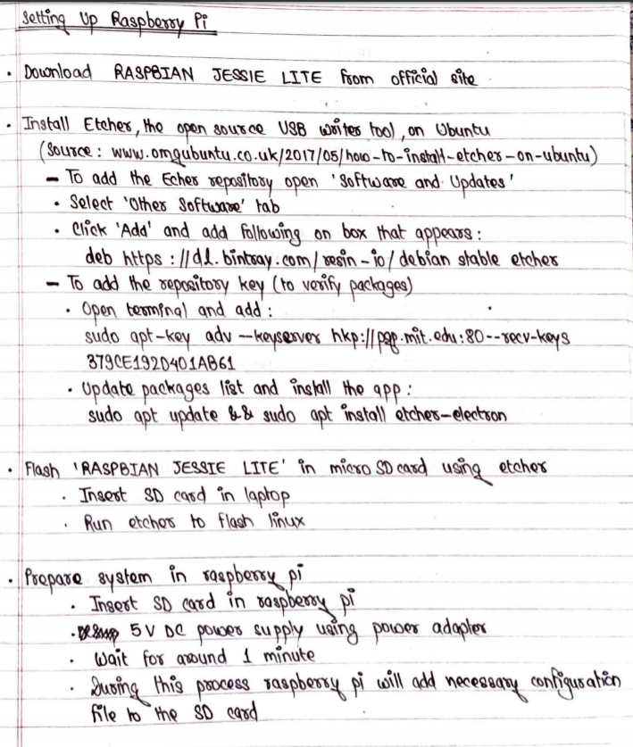

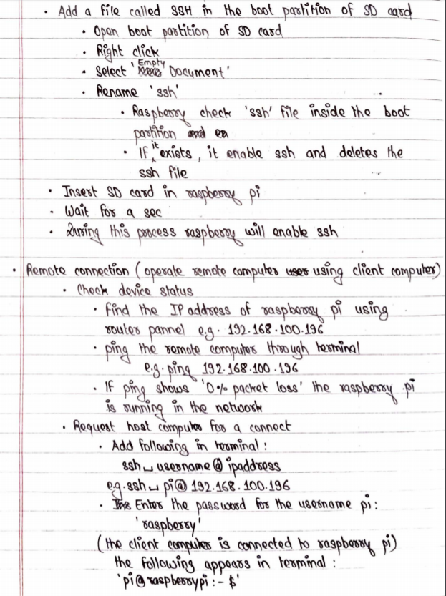
https://www.omgubuntu.co.uk/2017/05/how-to-install-etcher-on-ubuntu

